GIT BRANCHING

21.First take a backup of your assignments & projects.This is required because due to incorrect Git operation you may lose your files.

22.Create an empty directory ‘assignments’& cd to ‘assignments’

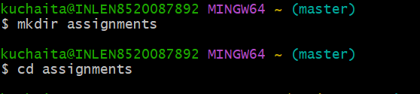

23.Create a readme.txt inside ‘assignments’ & write few lines about the contents of ‘assignments’ folder.

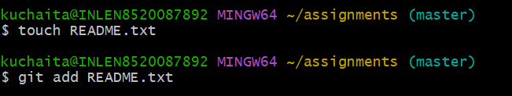

24.Commit readme.txt file.

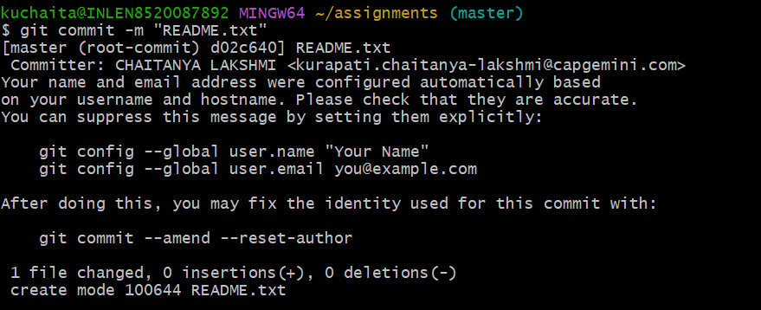

25 Now create a new branch ‘html-assignments’



26.Switch to ‘html-assignments’branch.

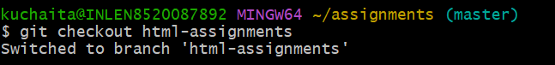

27.Copy all HTML assignments inside ‘assignments’folder.

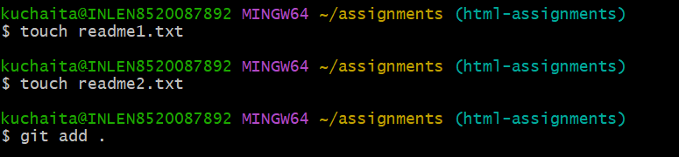

28.Commit HTML ASSIGNMENTS INTO ‘HTML-ASSIGNMENT’BRANCH.

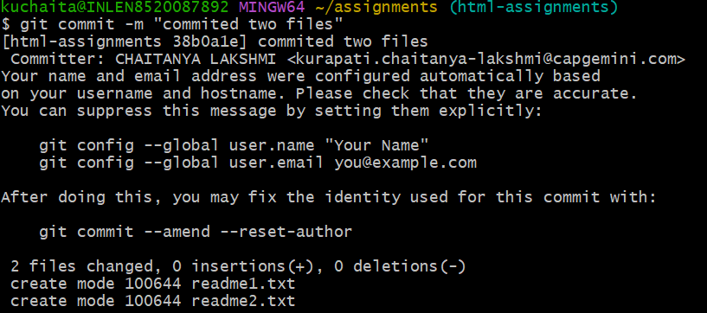

29.Make minor changes into few lines belongings to ‘html-assignments’ branch.

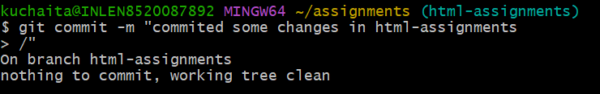

30.commit those changed files.

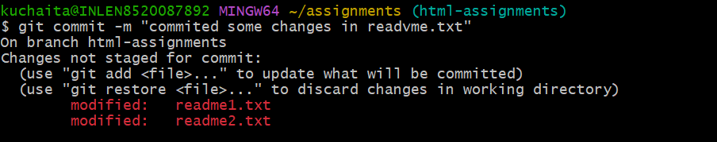

31.switch to master branch.

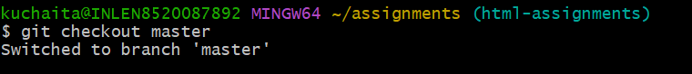

32.Make minor changes into README.txt file & commit those changes into master.

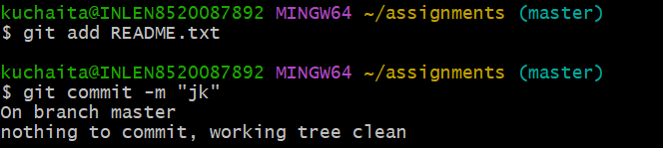

33.again switch to ‘html-assignments’branch.

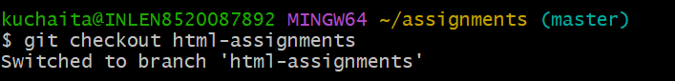

34.make minor changes into few belongings to ‘html-assignments’ branch.

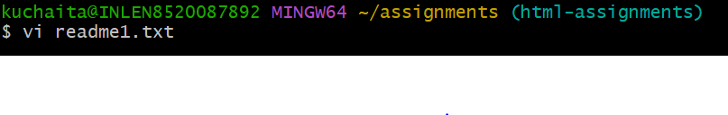

35.Commit those changes.

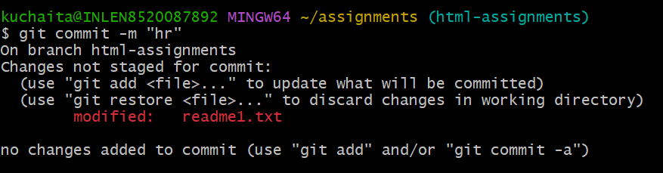

36switch to master.

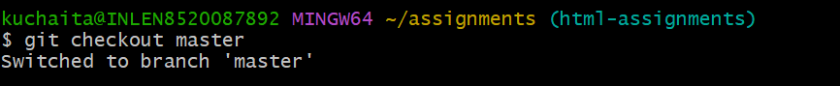

37.Merge ‘html-assignment’branch into master confirm all html assignments are shown in master.

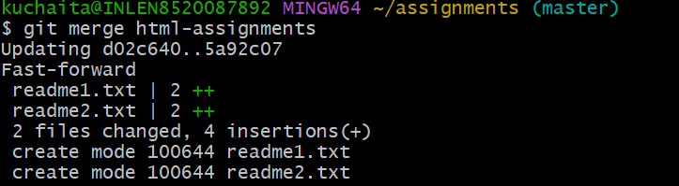

38.Finally delete the ‘html-assignment’ branch.

